
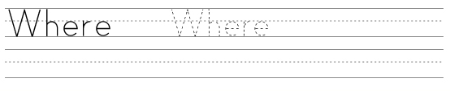
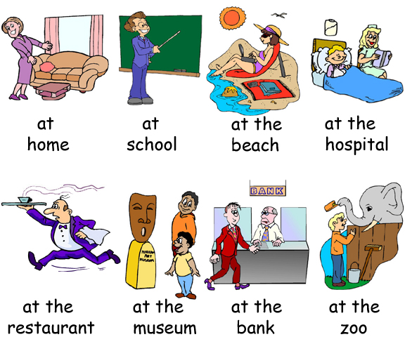

Go to bed
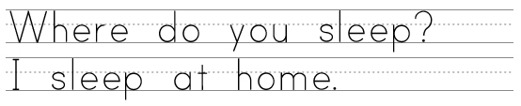

Study


Talk to a doctor

Save money
See monkeys
Swim
See statues
Order food
Eat breakfast
www.bogglesworldesl.com

