
©2004 First School Years (www.firstschoolyears.com)
©2004 First School Years (www.firstschoolyears.com)
©2004 First School Years (www.firstschoolyears.com)
©2004 First School Years (www.firstschoolyears.com)
The Sun
The Stars
Candle
Torch
Sources of Light
Sources of Light
Sources of Light
Sources of Light

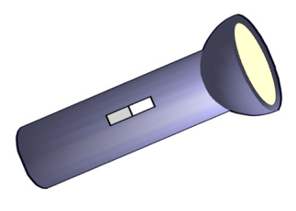
©2004 First School Years (www.firstschoolyears.com)
©2004 First School Years (www.firstschoolyears.com)
©2004 First School Years (www.firstschoolyears.com)
©2004 First School Years (www.firstschoolyears.com)
Lamp
Street Light
Television
Camera Flash
Sources of Light
Sources of Light
Sources of Light
Sources of Light
