Introduction to Forces

A force is a _____ or a ______.
We use forces to do a lot of work in our daily life.

Write either push or pull below each picture.

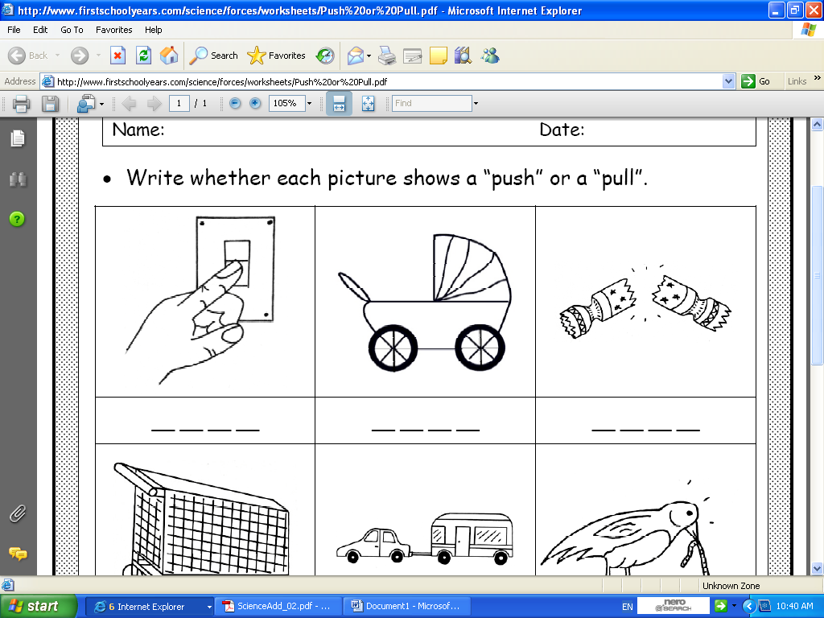 ___________ ____________ __________

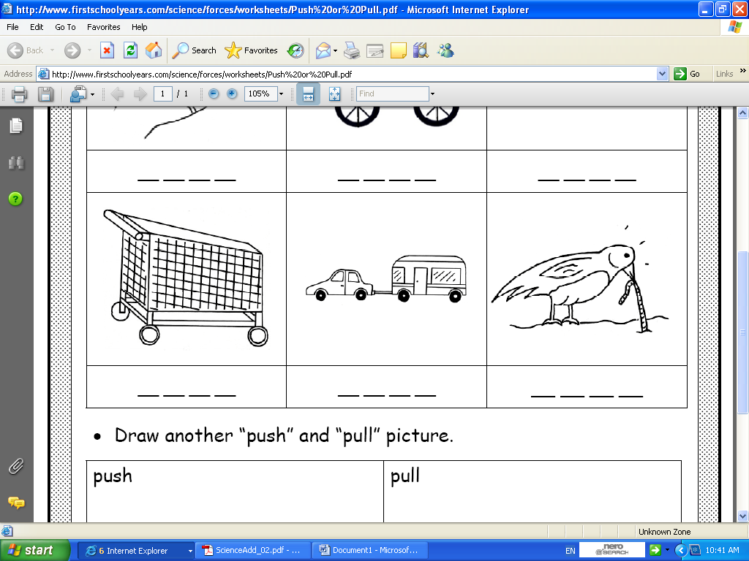
___________ ____________ __________

Complete the table below.

Name of Object | Push | Pull
Door | X | X
Keyboard | X
Kite |  | X
Doorbell
Ball
Pen

