
Fabrics & their Raw Materials

Name: Date:

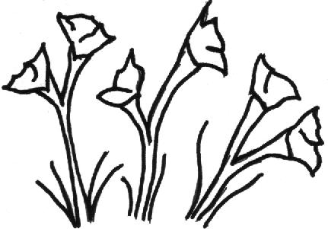
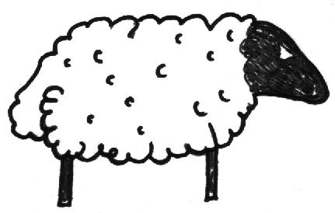
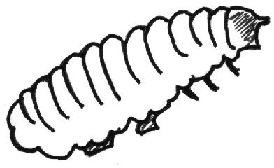
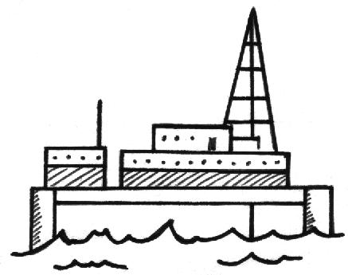
- Match each fabric to its raw material. Draw something which is made with each fabric.
2001 First School Years (www.firstschoolyears.com) This worksheet may be reproduced without permission for use in schools.

WOOL

SILK

COTTON

NYLON

