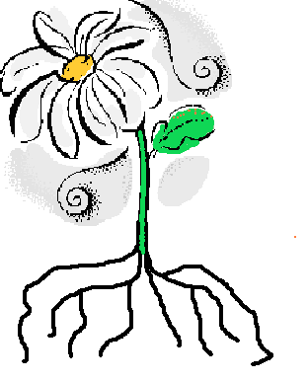
5
1

4

3

2

Flower Game

- Take turns to roll the dice.
- Find the correct label to match the number on the dice and place it on your flower.
- If you roll a six throw again.
- Continue taking turns to roll the dice.
- The first person to put all the labels on their flower in the correct place is the winner.

Cut these out to play the game.
Flower
Leaf
Roots
Stem
Seeds

