Glossary | Some properties of materials;  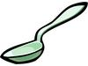  The metal spoon is shiny, hard and cold.    The plastic bin is smooth, bendy and hard.  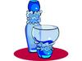  The glass bottle is see-through, hard and brittle.    The wooden chest of drawers is hard, warm and firm.  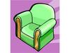  The leather arm chair is soft, smooth and squashy.  Can you think of others? | Some materials are attracted to a magnet.  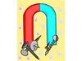  Materials are said to be magnetic or non-magnetic.  Non-metals are non-magnetic.  Only some metals are magnetic.  Do you know which ones? | 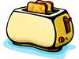  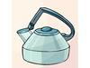      Some ways of changing materials;  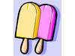  We can freeze fruit juice to make lollies.  We can boil water.  We can toast or fry our bread.  We can burn wood.  We can rip, tear and cut our clothes.    We can slice, chop, grate, dice and shred our food.  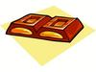  We can melt chocolate!
property – a characteristic of a material e.g. hard, bendy, shiny etc.
group – materials can be placed in groups based on their properties e.g. wood, metal, glass etc
changing materials e.g. squash, bend, twist, stretch, heat, cool, freeze, melt, boil
natural – when a material is used in its raw state e.g. wooden door
manufactured -
when a raw material is made into a new one e.g. wood into paper
raw material - a material found in nature e.g. wood

