Glossary | The anorak is made from fabric.  The scissors are made of metal.  The chair and the table are made of wood  A book is made from paper.  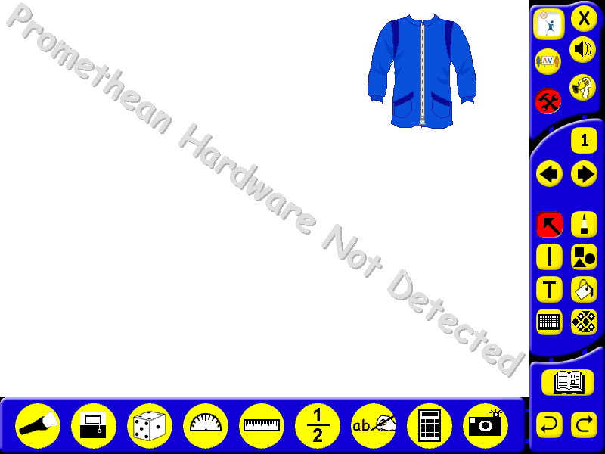  A plant pot is made of clay | Which is the strongest?  A metal spoon or a  plastic spoon?  Which is the smoothest?  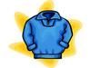  A rough  woolly jumper or a smooth silk blouse?  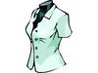 | Look at these words:  Hard, soft, rough, smooth, shiny, dull, magnetic, transparent, bendy, waterproof and strong.    Can you match the words to the pictures?  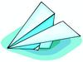  What other things could you describe using these words?
materials - are found all around us and are used to make everyday things

wood - comes from trees used for chairs and tables

glass – a see-through material used for windows

plastic – is smooth and can be made into many shapes, used for cups

metal - is a hard material which is shiny and is used for knives and forks

